All,

On December 6th, all RENCI email & calendar will officially be migrated to Office 365 (Cloud). Your RENCI email & calendar will be merged with your UNC email & calendar. The Office 365 service is provided by UNC. Moving forward an ONYEN and UNC Email will be required in order to access RENCI email & calendar.

PROCESS & DATES: The migration procedure will be a 2-phase process:

Phase-1 (11/16/2018):
- ACIS begins “pre-staging” your UNC inbox by importing all RENCI email & calendar (sent/received from the time you started at RENCI through 11/16/2018) into your UNC Email account. – Your UNC inbox will begin to reflect your RENCI inbox.
- No user interaction is required, as this is done in the background.
- RENCI users can continue using their RENCI email/calendar & UNC email/calendar, separately, as normal.
Phase-2 (12/6/2018 @ 6:00PM):
- ACIS begins final “gap” export/import of RENCI email & calendar sent/received between 11/16/2018 through 12/6/2018 @ 6PM.
- Starting at 6:00 PM on 12/6, you should avoid using email, but if you need to access your RENCI email, it MUST be done via heelmail.unc.edu.
- Friday morning (12/7/2018), all RENCI email will be synced with O365 and accessible via heelmail.unc.edu and mail clients.
- RENCI’s On-Premises Exchange servers retired. All RENCI mail & calendar services now handled through UNC’s Office 365 subscription.

WHAT DO I NEED TO DO/KNOW?

UNC Account:
- All RENCI employees (and outside affiliates/contractors that utilize a RENCI email account) must have a UNC ONYEN & UNC Email address.
- Onyen: Go to https://onyen.unc.edu to verify the status of your ONYEN or create one if you do not have one.
- Create a UNC Email account (if you don’t already have one): Log into https://selfservice.unc.edu/ using your ONYEN and Password. Click on “Email Sign-Up” on the left hand menu.
- If you run into any problems you can contact help.unc.edu or call UNC Help (919.962.HELP).

2-Step Verification for Office 365 (Heelmail) (MFA – Multi-Factor Authentication):
- 2-Step Verification is required to access your email via heelmail.unc.edu, Outlook, Thunderbird, Apple Mail, Android Email App, & iPhone Email App.
- Instructions for configuring your 2-Step Verification can be found by logging into https://onyen.unc.edu and clicking on “2-Step for Office 365 (Heelmail)”.
- If you run into any problems you can contact help.unc.edu or call UNC Help (919.962.HELP).

Day of Migration Thursday (12/6 @ 6:00PM):
- ACIS begins export/import of RENCI email & calendar sent/received between 11/16/2018 through 12/6/2018 @ 6PM.
- Starting at 6:00 PM, you will not be able to send or receive email, using your existing RENCI account profile (username@renci.org), either through a mail client or webmail.renci.org.
- At this time, you should avoid using email, but if you need to access your RENCI email, it MUST be done via heelmail.unc.edu.
- When logging into Heelmail, you may find that the past three weeks of your RENCI email is not in your inbox. It may take a few hours for the final “gap” import to sync to O365. Your remaining email will be available in your inbox by Friday morning (12/7).

Accessing your Email/Calendar on Friday (12/7):
- Your existing RENCI account profile (username@renci.org) must be removed from your mail client (i.e. Outlook, Thunderbird, Android App, or iPhone App).
- Your UNC O365 Email account (username@renci.org) will need to be added to your preferred mail client. If you already have your UNC account added as onyen@unc.edu, it will need to be removed and added again as username@renci.org.
- ACIS will be onsite and available to assist with any help that may be needed in accessing or configuring your email.

After the migration & Your @renci.org Email address:
- After the migration, you will still be able to send/receive emails using your @renci.org email address, by setting your username@renci.org as the Primary Alias from the steps above.
- If you do not set your UNC Primary Alias, all of your mail will be sent/received as onyen@unc.edu.
- You will continue to receive email sent to all of your UNC aliases, including your new @renci.org alias.
- Your RENCI & UNC email/calendar will flow through the same account.
- You’ll need to use 2-Step Verification to access your email:
  - Once during the initial setup of your mail client, then every 90 days when you’re required to change your Onyen password.
  - Every time you sign-in to heelmail.unc.edu. Note that after 12 hours of being signed into HeelMail, you will automatically be signed out. This is regardless of activity.

Help & Information:
- Office 365 Features: https://office365.unc.edu/
- Office 365 User Guide: https://help.unc.edu/help/office-365-user-guide/
- Office 365 FAQ: https://help.unc.edu/subject/office365/
- UNC Help: https://help.unc.edu (Phone: 919.962.HELP)
- RENCI Wiki: https://wiki.renci.org
- RENCI Help: help@renci.org

Remove Existing Email Accounts from Outlook (Windows)
- In Outlook, click File in the top-left.
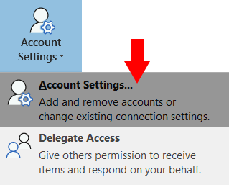
- Under Info, click the Account Settings button, then select Account Settings, again.

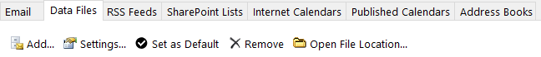
- In the Account Settings window that appears, click on the Data Files tab at the top, then click Add…

- In the succeeding pop-up window, leave the default file name and click OK.

- In the same Account Settings windows, click on the Email tab at the top, select your @renci.org account, then click Remove.
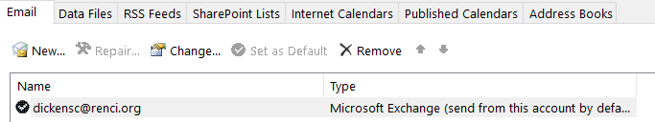
  - If you also have your UNC Email account in Outlook, you must remove this too.

- After you click Remove, an alert will appear, stating “Careful, if you remove this account, its offline cached content will be deleted.” Click Yes

- After your RENCI and UNC email accounts have been removed, close the Outlook client.

Add your RENCI Email to Outlook (Windows)
- Open the Outlook Client.
- In Outlook, click File in the top-left.
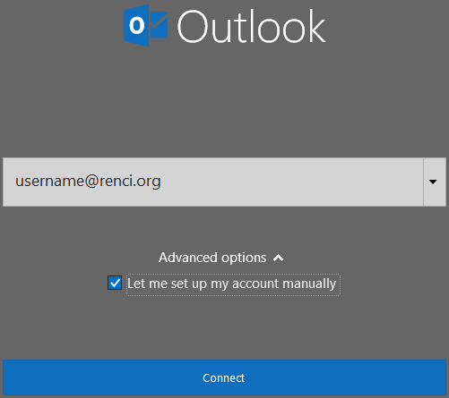
- Under Info, click
- In the Add Account pop-up window, do the following
  - Enter your RENCI email address (if not already populated).
  - Click on Advanced option, then check/select Let me set up my account manually.
  - Click on Connect.
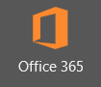
- In the Advanced setup pop-up window, click on
- On the Enter Password pop-up window, click on Sign in with another account, in the bottom-left.
- On the following window, under Work or school account, enter your onyen@ad.unc.edu (using your assigned UNC Onyen). Then click Next.
- You’ll be redirected to UNC’s authentication page. Type in your Onyen password, then click Sign-In.
- Wait for your chosen method of 2-Step Verification.
- After you’ve authenticated your Heelmail account, you will be redirected back to the Enter password pop-up window. Again, click on Sign in with another account and select your UNC Onyen account.
- On the Exchange Account Settings window, leave the default values and click Next.
- Click Done on the next window.
Your RENCI email will now be visible in Outlook. It will take several minutes for all of your email and calendar to sync with Outlook. If you need immediate access to your email, you can access your email via https://heelmail.unc.edu.
Remove Existing Email Accounts from Outlook (Macintosh)
- In Outlook, click Outlook and Preferences… in the top menu bar

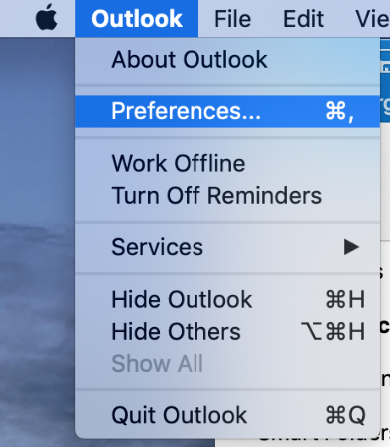

- Click Accounts from the top row of Outlook Preferences

- Click the - in the bottom left corner of the Accounts window and confirm the deletion.
Delete both RENCI and UNC accounts, if connected.

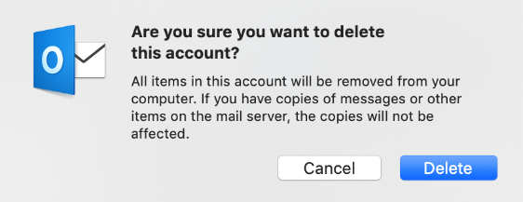

Add your RENCI Email to Outlook (Macintosh)
- Click Add Email Account

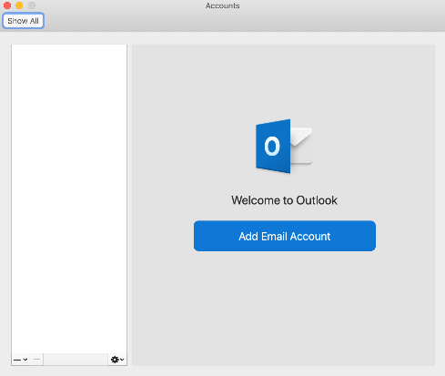

- Enter your RENCI username and click Continue

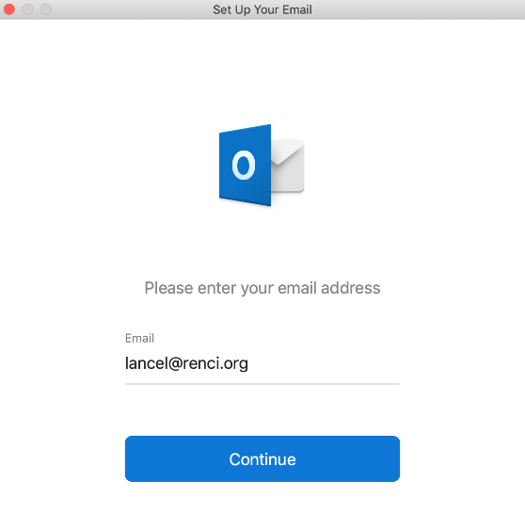

- When it asks for your password click Sign in with another account

- Sign in with your UNC ONYEN (ONYEN@ad.unc.edu) and finish the 2-step authentication

